Indexing Assignment
Insert the following documents into a collection named books:
db.books.insertMany([
{ Pub_no:101, title: "MongoDB Basics", tags: ["database", "nosql", "mongodb"] },
{ Pub_no:102, title: "Advanced MongoDB", tags: ["mongodb", "performance", "indexing"] },
{ Pub_no:103, title: "Web Development", tags: ["html", "css", "javascript"] }
])
- Create a single-field index on the title field.
- View all indexes on the books collection.
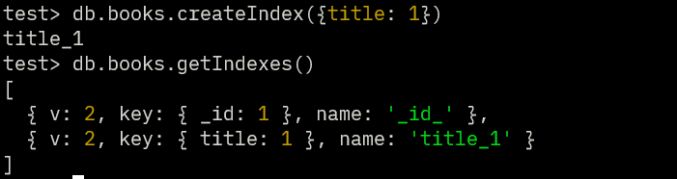

- Compare the performance.
Before:
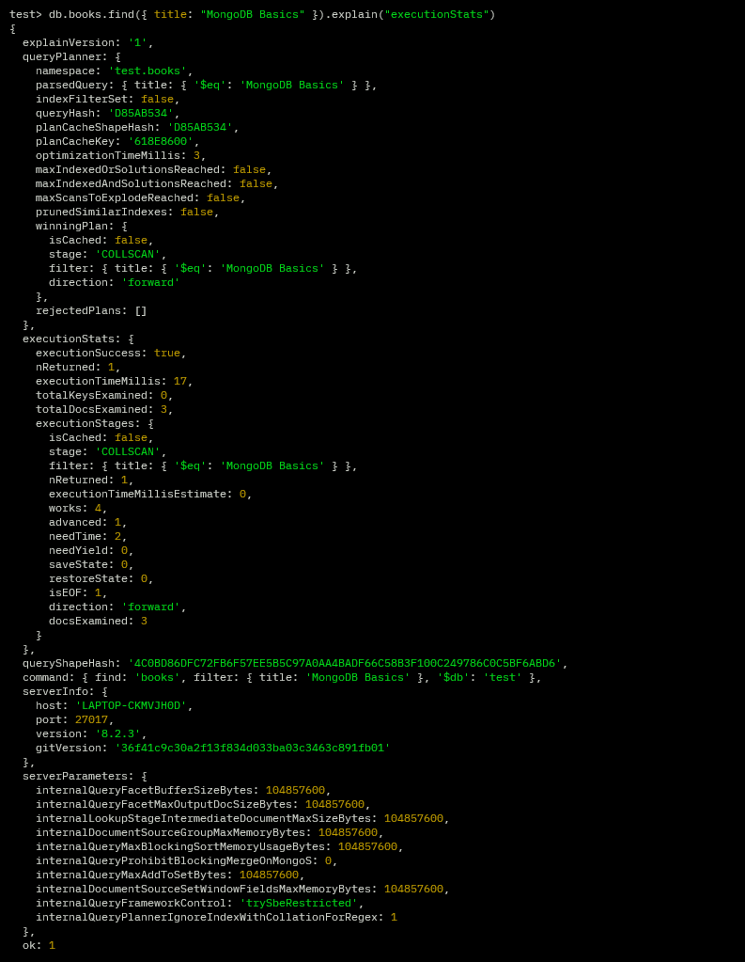

After:
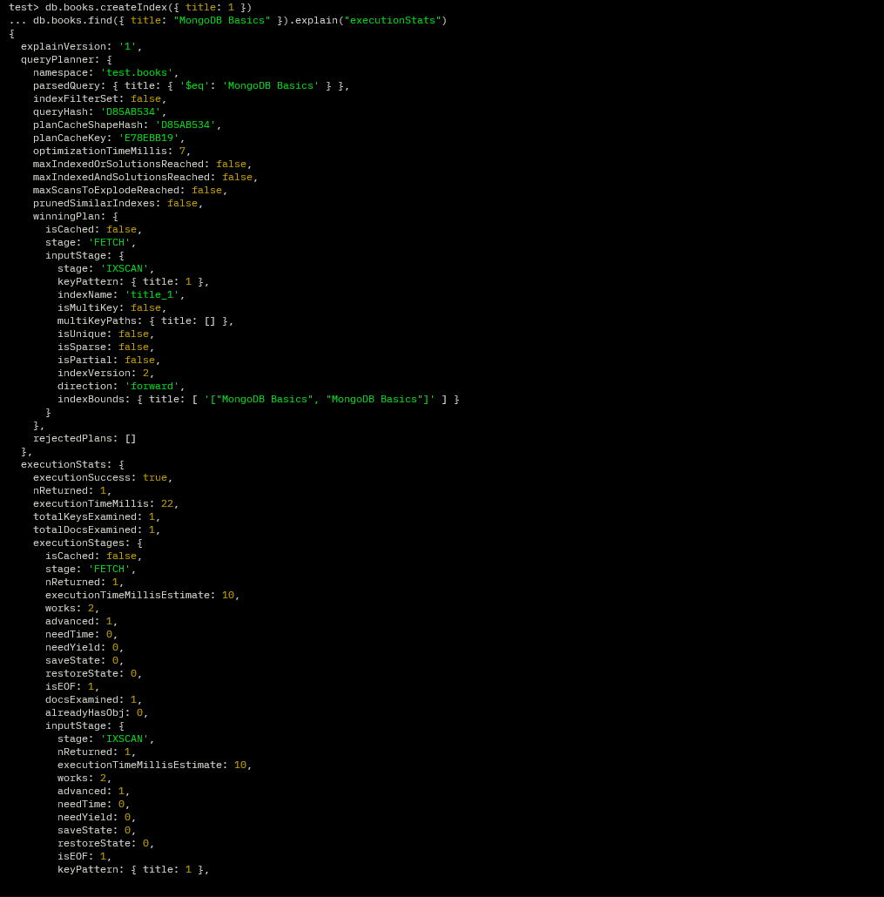

- Drop the index.
- Create a compound index on Pub_no and title.
- Write and test a query that takes advantage of this index
- Create an index on the tags array field.

- Run a query using one of the tags.
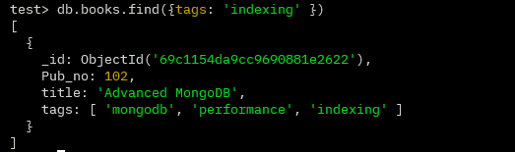
• Answer the questions:
- What type of index is automatically created on an array field?
Ans: _id
- How does MongoDB handle indexing arrays?
Ans: It creates a multikey index, indexing each element of the array as a separate index entry.
- Can multikey indexes be compound with another multikey field? Why or why not?
Ans: No—MongoDB allows only one array field in a compound index to avoid combinatorial explosion of index entries.
- When would you prefer a compound index over multiple single-field indexes?
Ans: When queries filter/sort on multiple fields together, since compound indexes are more efficient than index intersection.

Aggregation Assignment
Use a collection named orders in database ecommerceDB:
db.orders.insertMany([{
order_id: 1,
customer: "Aman",
city: "Delhi",
items: [
{product: "Laptop", price: 70000, quantity: 1},
{product: "Mouse", price: 500, quantity: 2}
],
total_amount: 71000,
status: "Delivered"
},
{ order_id: 2,
customer: "Riya",
city: "Mumbai",
items: [
{product: "Phone", price: 30000, quantity: 1}
],
total_amount: 30000,
status: "Pending"
},
{ order_id: 3,
customer: "Karan",
city: "Delhi",
items: [
{product: "Tablet", price: 20000, quantity: 1},
{product: "Cover", price: 1000, quantity: 1}
],
total_amount: 21000,
status: "Delivered"
} ])

Q1. Write an aggregation query to retrieve only orders with status "Delivered"

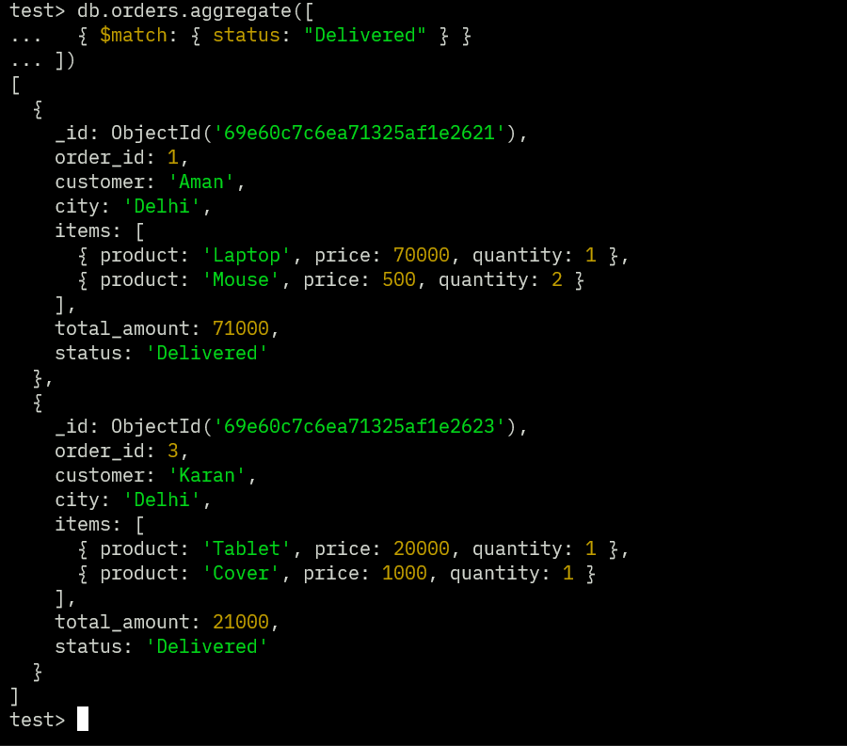

Q2. Calculate total revenue generated per city.

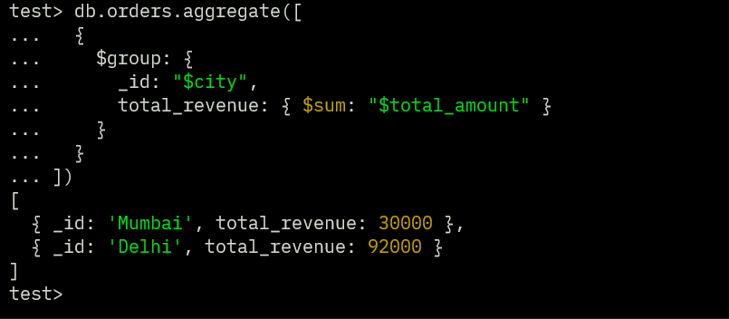

Q3. Sort customers based on total_amount in descending order

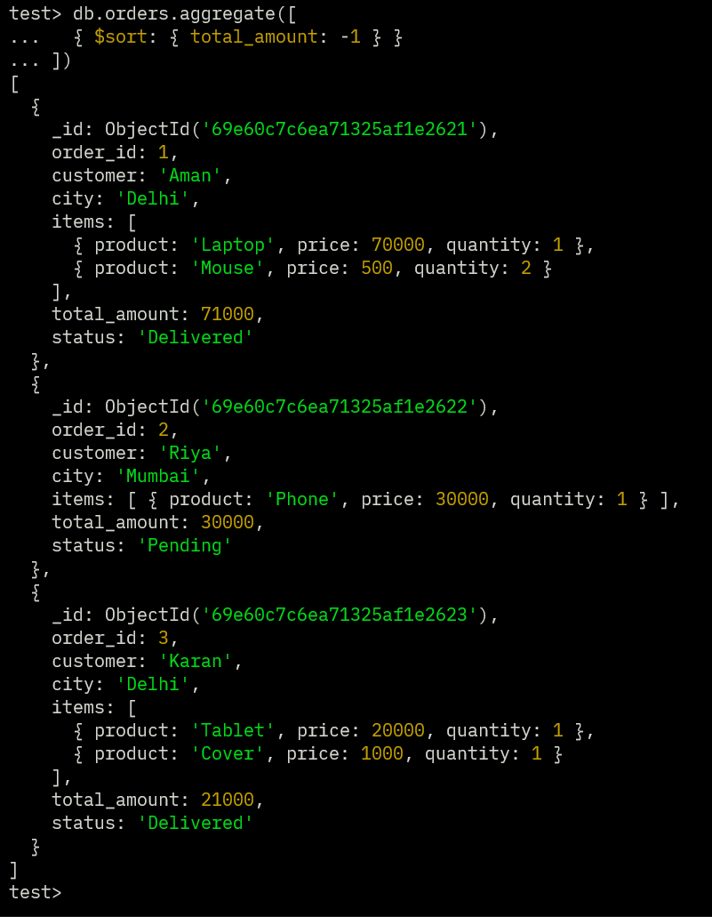

Q4. Display top 2 highest value orders

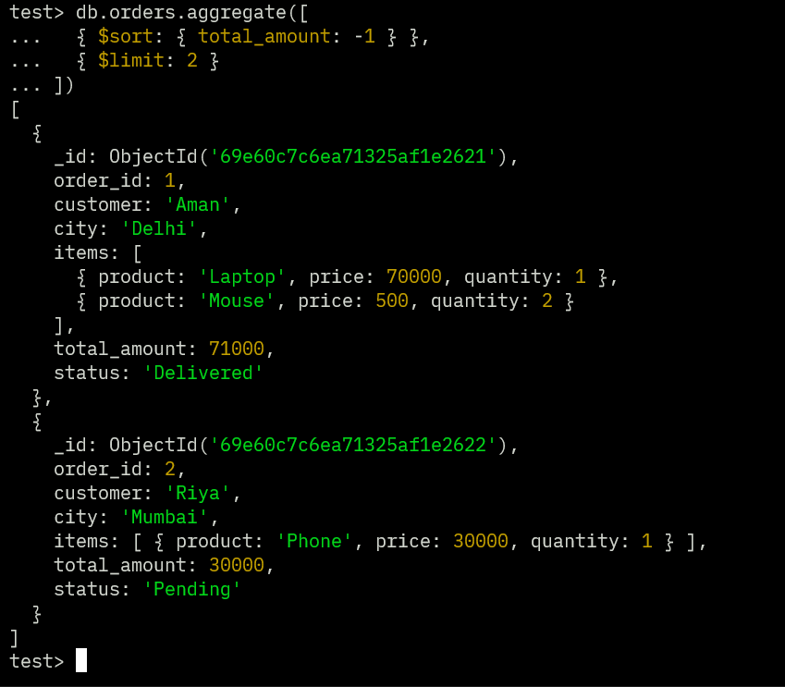

Q5. Skip the first order and display remaining records.

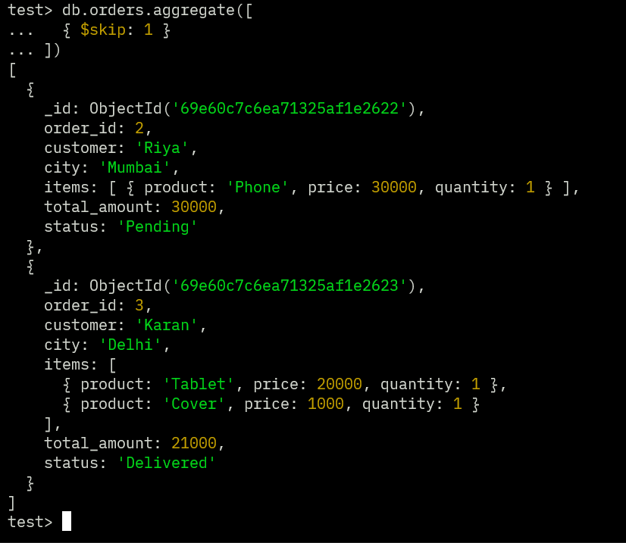

Q6. Flatten the items array and display each product as a separate document.

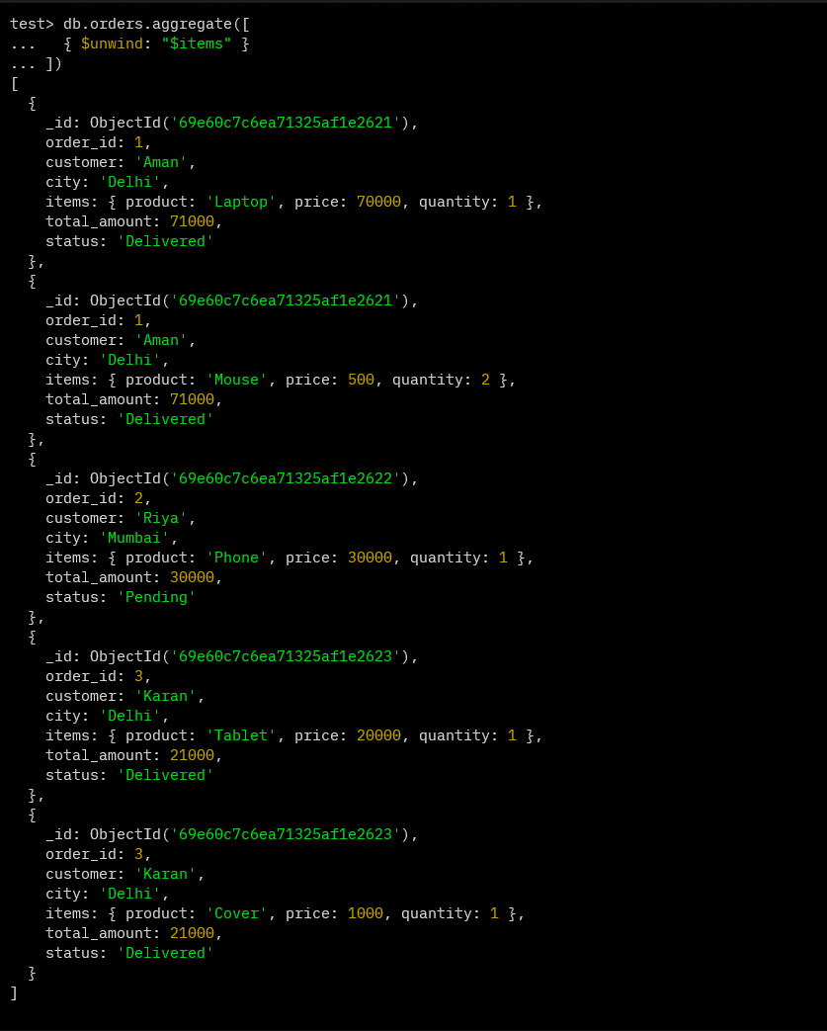

Q7. Write a pipeline to:
- Unwind items
- Filter ($match) items with price > 10000
- Group by product and calculate total quantity sold
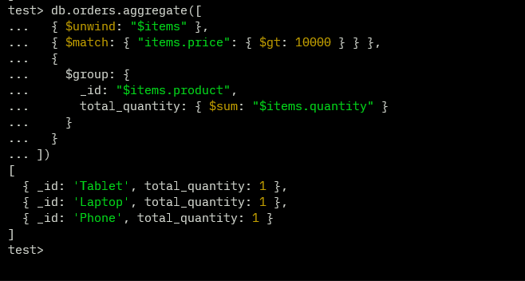

Q8. Group orders into categories based on total_amount:
- 0–20000 → "Low"
- 20000–50000 → "Medium"
- Above 50000 → "High"
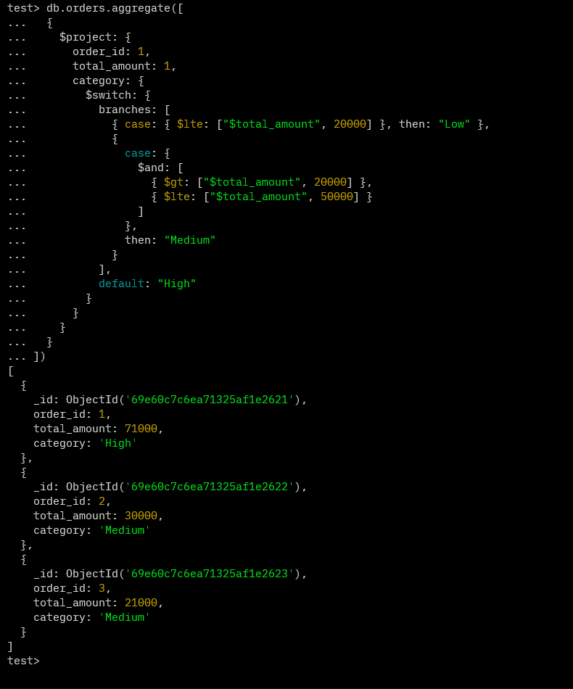

Q9. Store aggregation result (total revenue per city) into a new collection named cityRevenue

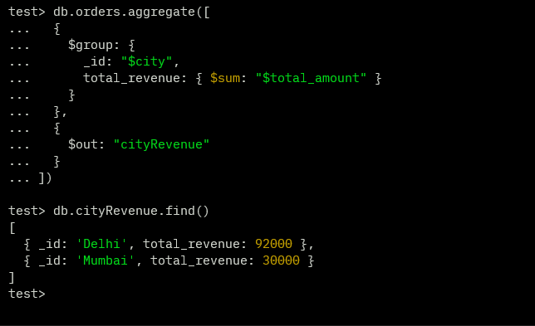

Q10. Merge aggregation results into a collection citySummary and Update existing documents if present

